Github Assignments

1. Create a directory ‘project_dir’ & cd to ‘project_dir’.

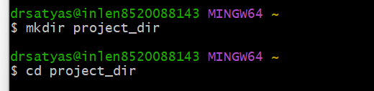

1. Initialize git version database.(git init)

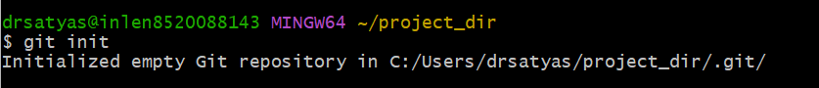

1. Create a new file index.html

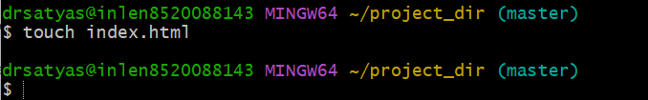

1. Check the git status. You should find index.html as untracked file

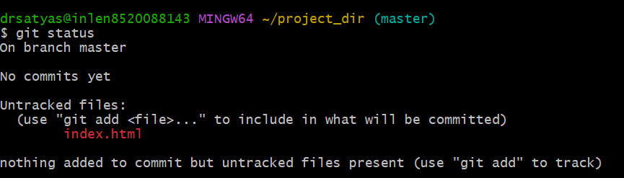

1. Stage the index.html file



1. Commit index.html

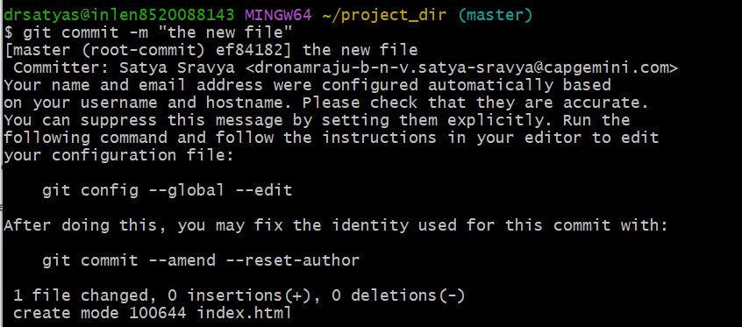

1. Make few changes in index.html & create a new file info.txt file

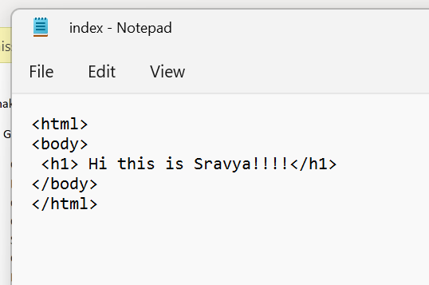

Creating info.txt file

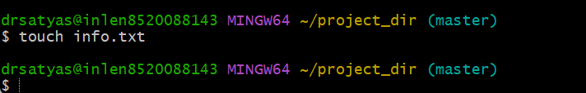

1. Check git status. You should find index.html & info.txt as untracked file

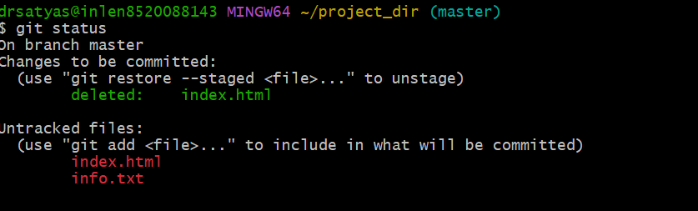

1. Configure git to ignore all txt files.

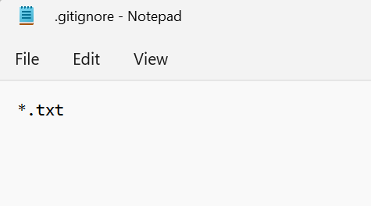

1. Again check the git status. You should find only index.html as untracked file

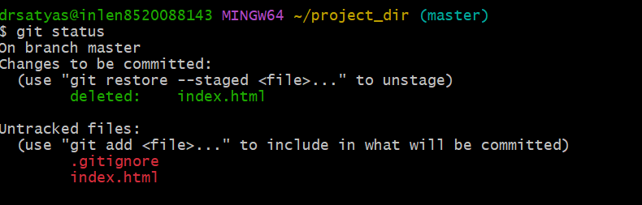

1. Stage and commit index.html

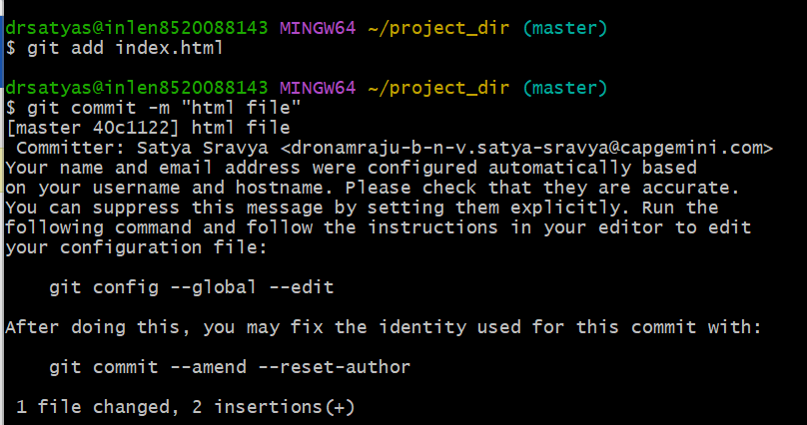

1. Log all your comments so far

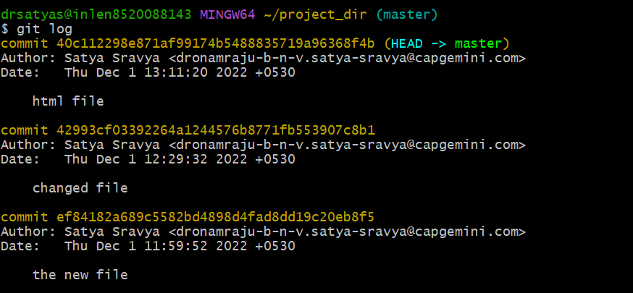

1. Make some changes in index.html

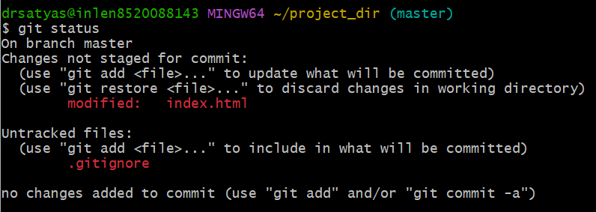

1. Revert the change made in the previous step using git command

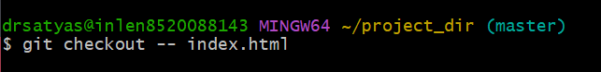

1. Again Change index.html

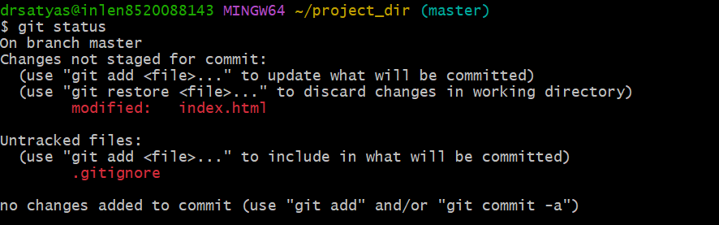

1. Stage index.html

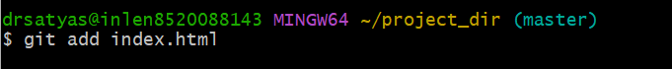

1. Revert back the last stage

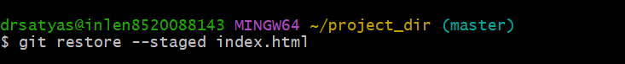

1. Rename ‘add’ command to ‘my-add’



1. Using my-add command stage index.html again and commit the changes

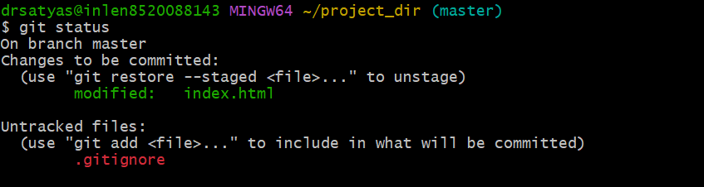

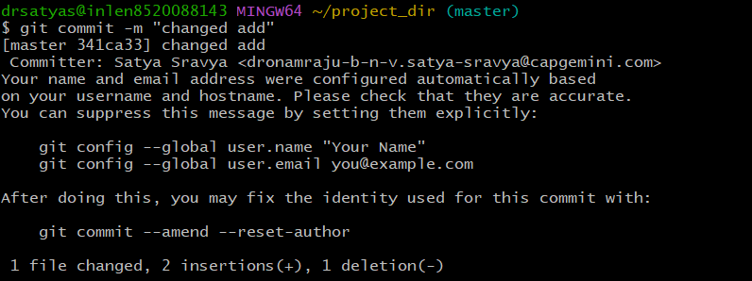

1. revert the last commit

